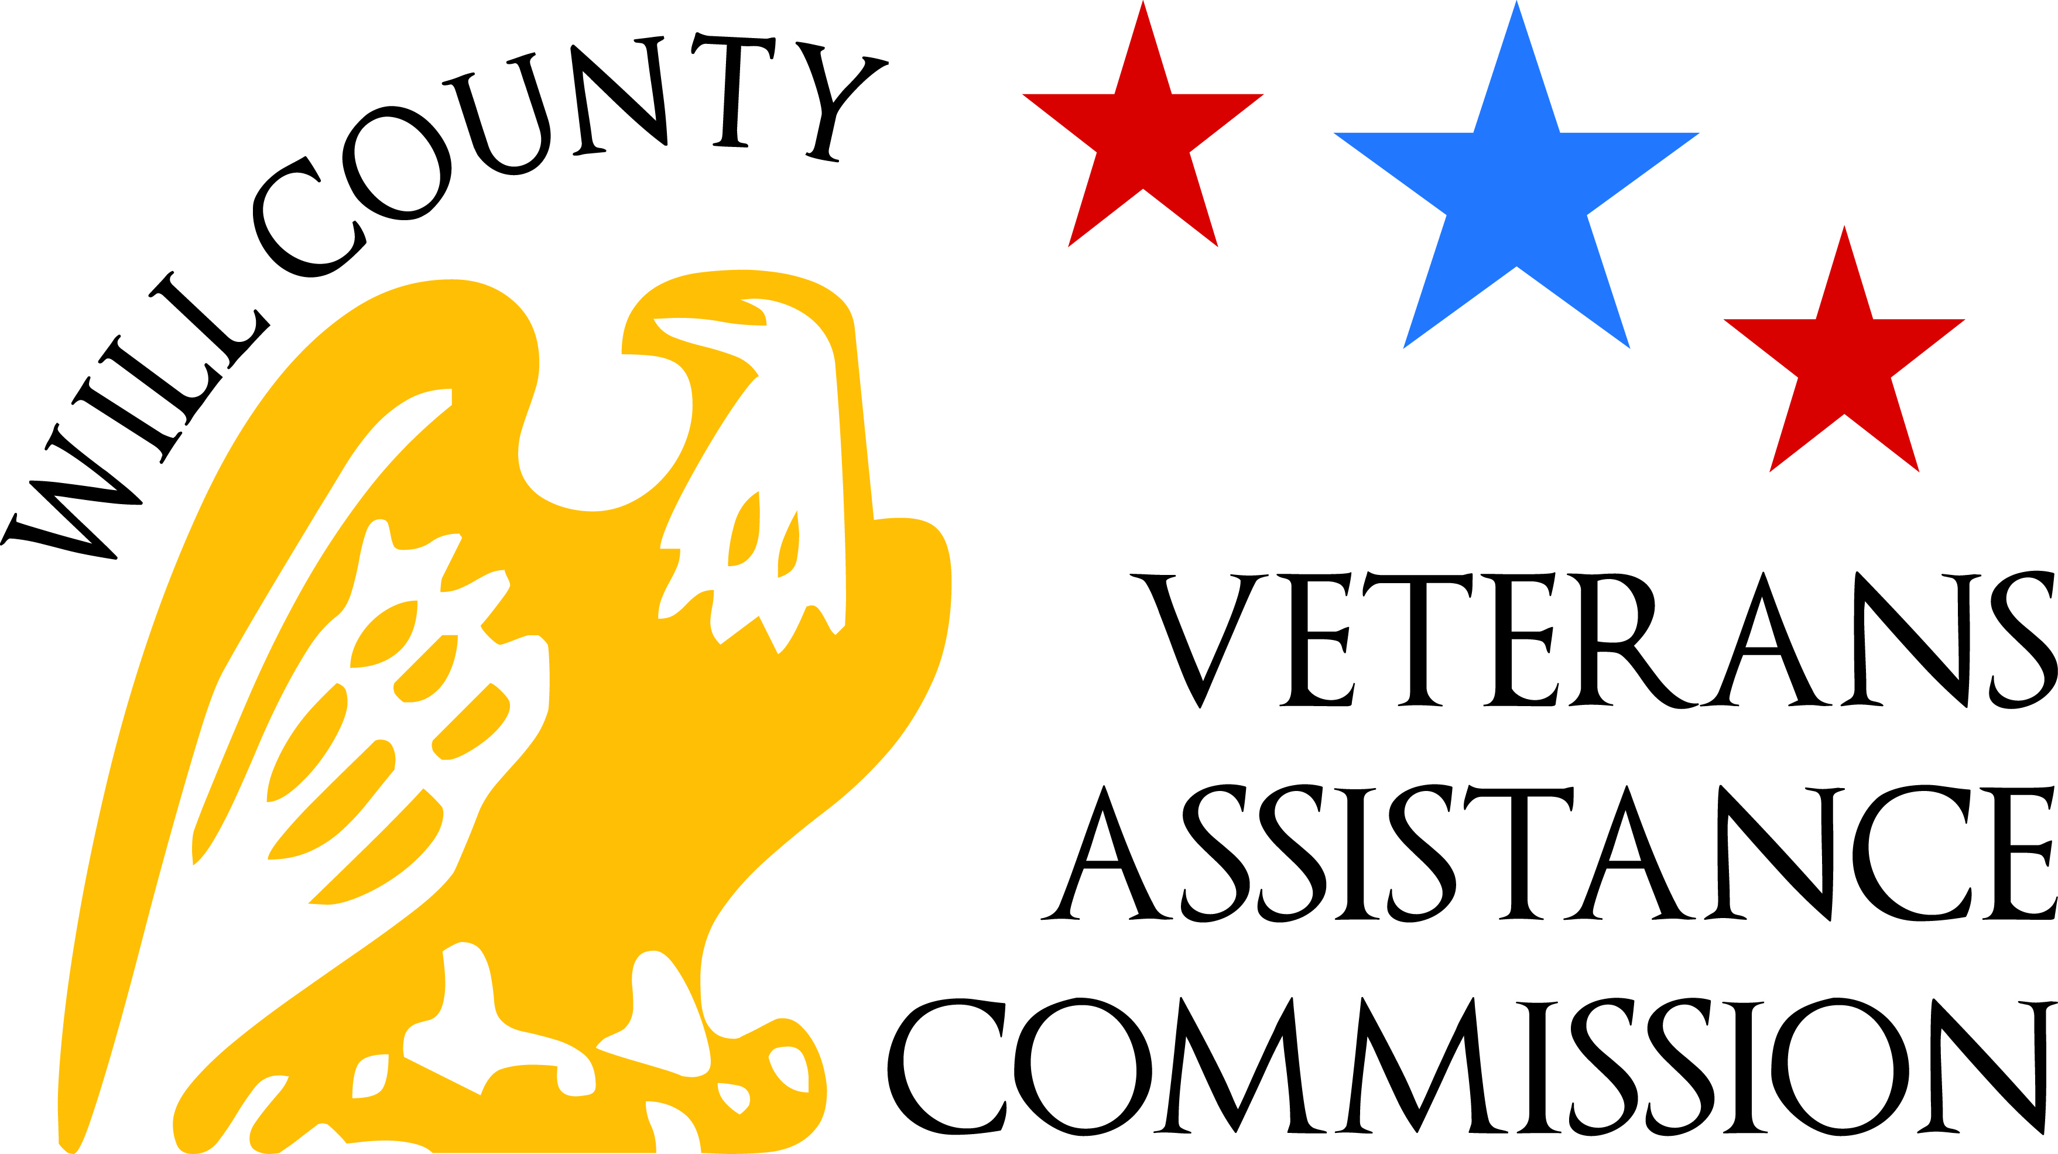
Veteran Assistance Commission
of Will County
Kristina McNichol – Superintendent
Glenwood Center 2400 Glenwood Ave. Ste 110 Joliet, IL 60432
Ph: (815)740-8389 Fax: (815)740-4329

13 April 2021 | Commission Meeting | 7:00 PM
In accordance with Executive Order 2020-18 issued by Governor Pritzker, meetings will be held via videoconference/telephonically through the ZOOM Meeting platform. VAC Will County Board Members will be attending meetings remotely and the general public is strongly encouraged to do the same. If a member of the public would like to attend the meeting virtually, please send an email to vacwc@willcountyillinois.com and a link will provided.
- Call to Order: Jack Picciolo @ 707AM
  - Pledge of Allegiance
  - Opening Prayer: Member Mlynek
- Roll Call of Attendees: Secretary Williams
VAC Commission
Attendee Name | Title | Status
Jack Picciolo | President | p
Nicholas Barry | Vice President | P
Denise Williams | Secretary | P
Amanda Koch | Sgt-At-Arms | P
Jim Singler | Chaplain | A
Tom Mlynek | Member | P
Janet Blue | Member | P
Steve Benicke | Member | A
Vic Martinka | Past Chairman | A
John York | Past Chairman | A
Wayne Horne | Past Chairman | P

- Introduction of Guests and/or First Time Attendees:
Raj Pillai; GWOT Navy Vet, AL13, CPA
Eva Savickas; The Cognitive Clinic, office manager

- Minutes of Previous Meeting (9 Mar @ 7:00pm)
  - Motion: Koch, Mlynek; unanimous

- Superintendents Report:
  - Financial Assistance Second Qtr 2021; Will Review @ 5/11/2021 Commission Meeting

  - Award/VSO Productivity:
So far, working back to 2015; since just over $82million; pulling reports for DIC to account veterans who have passed; each VSO is completing/following up on their own veterans, contacting proactively; Papineau advised quarterly improves accounting, accuracy

  - Project165 Report Valerie Tawrel
Tawrel advised currently 11 veterans, 4 are families, at Quality Inn; advised when eviction moratorium is lifted, may be inundated; one vet/family was at motel for 18 months, is now in permanent housing; all remaining veterans have housing plans except one;
Motion: Horne, Barry; unanimous

- New Business
  - DCEO grant
McNichol advised grant technically expired 12/2020, now extended to 5/1/2021; will use funds
to purchase gym equipment, to be stored at old Joliet office building in the interim

- Old Business
  - By-Law Discussion/Review: Atty. Lisa McGlasson
Discussion of Elected Officers/members, quorum, Past Chairman; member Blue advised Past Chairman are elected in the past, not currently; member McGlasson advised if Past Chairman are listed as members, they can fulfill the requirement of the two members needed for quorum; Horne suggested clarification/limitation, last three Past Chairman, formality of voting rights, could become obstructionist; discussion of role of Past Chairman; discussion of maintenance of residency could be added for current Officers; consensus is to leave as is for now, reserve for future discussion; discussion of Superintendent;
Motion to accept the Bylaws: Blue, Barry; unanimous
Member McGlasson will return final edited copy to Exec. Board for reference by 4/16/2021

  - CARES Funding Update
McNichol advised will present to/with Will County Land Use next week to expand/add to the $1.5 million; advised hotel project continues;

- For Good of the Commission/Public Comment
Mylnek-work w/Raj Pillai, request a presentation on JROTC for his post/VAC
Williams – advised 4/23-24 “Watch” at MiddleEast Conflict Wall; Memorial Day ceremony has been cancelled for ALNC, MiddleEast Conflict Wall is having ceremony on Memorial Day; ILMFR is permitted, scheduled for 19; AL13 Riders, AL District 11 motorcycle run 7/17/21; AllenForce motorcycle run 7/24/17
Blue – suggested VAC promoting JROTC in Will County community schools; McGlasson supports, they will be in contact with Raj Pillai

- Motion to Adjourn: Horne, Blue; Unanimous

VAC Executive Committee Meeting
5/11/2021
7AM
2400 Glenwood Ave STE 110 Joliet IL 60435
VIA Zoom

Respectfully Submitted,
Secretary Williams

