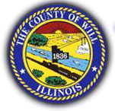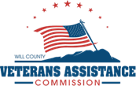Veterans Assistance Commission of Will County

2400 Glenwood Ave. Ste 110 Joliet, IL 60435

Ph: (815)740-8389 Fax: (815)740-4329

veteransassistancewillco.org

**September 23rd, 2024 Financial Assistance Policy Review Committee 3:00pm**

1. **CALL TO ORDER**
   1. Pledge of Allegiance
   2. Invocation

**ROLL CALL OF COMMITTEE MEMBERS:**

Steven Daley  
 Tony Arellano  
 John Davin  
 Rick Todd  
 Mark Razny

1. **INTRODUCTION OF GUESTS AND/OR FIRST TIME ATTENDEES**
2. **PUBLIC COMMENTS FOR ITEMS ON THE AGENDA**
3. **Review of previous minutes: Aug 7, 2024**
4. **NEW BUSINESS**
   1. **Review of Proposed VACWC Financial Assistance Policy**
      1. **Discussion**
5. **MOTION TO ADJOURN**